Parent document: WI-00635
TempTale data loggers are used by Lifeblood when it is estimated that the transport time may exceed the validated transport time for the shipper configuration. Data loggers are placed amongst blood products measuring the ambient temperature in the shipper. This document is for reference only.
PLEASE RETURN ALL TEMPERATURE LOGGERS TO LIFEBLOOD AS SOON AS POSSIBLE.
Types of Data Loggers
Red
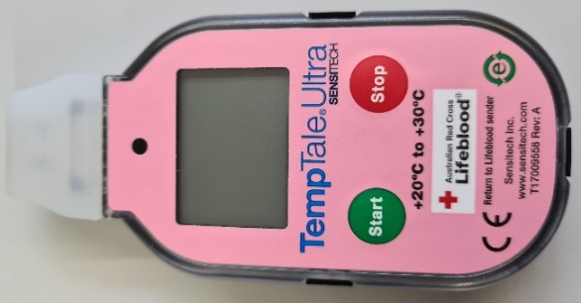 | Unconditioned components reducing to a temperature between +20°C to +30°C.
Green
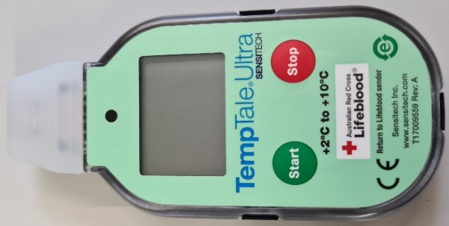 | Conditioned components transported between +2°C to +10°C.
Yellow
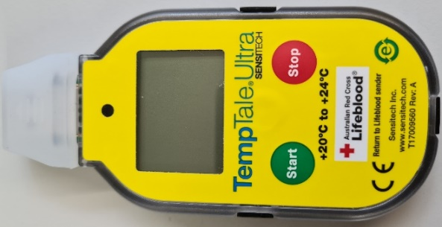 | Conditioned components transported between +20°C to 24°C.
White with blue rear cover
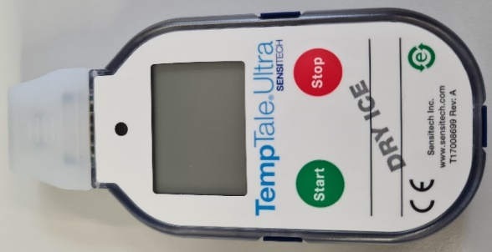 | Conditioned components transported at less than -25°C
Purple
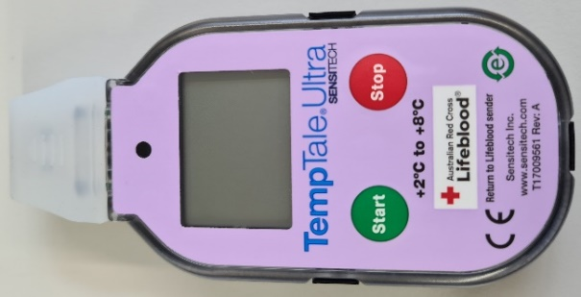 | Conditioned manufactured products transported between +2°C to +8°C
Orange
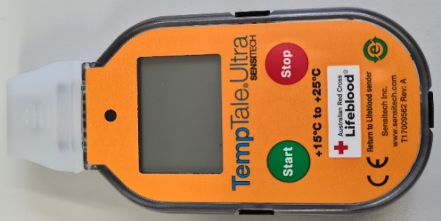 | Conditioned consumables transported between +15°C to +25°C
Remove the logger from the shipper
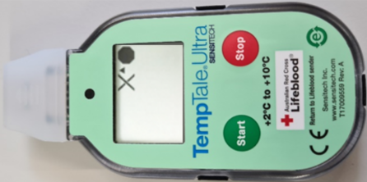 | - Press and hold STOP button (1-3 seconds) until the icon is displayed on the upper right corner of the LCD display.  - Ensure the icon has replaced icon on the LCD screen to confirm the data logger has been stopped  Note: White with blue rear cover data logger (Dry ice) the LED light will blink RED to indicate the data logger has been stopped
Check the logger LCD display screen
WITHIN LIMITS | If the consignment has been received within the validated time frame and/or remained within temperature then:  - check the contents have been packed according to Lifeblood Shipper configurations. Refer to Lifeblood Shippers - Receipt and Use by External Institutions (WI-00635).  - reconcile the contents against Lifeblood paperwork i.e. NBMS Issue Note.  The consignment is deemed acceptable for use
OUT OF LIMITS  or | If the consignment has not been received within the validated time frame and/or not within temperature range then product may not be acceptable for use.  - take a manual temperature of the contents.  - quarantine the products.  - download the logger information or return the logger immediately to Lifeblood for assessment.  - contact Lifeblood to inform of the discrepancy and request determination of the suitability of the product and/or request replacement of product.

